Topic | Minimum cost spanning Tree & Shortest path algorithm
Learning Objectives | The students can understand minimum cost spanning tree algorithms and shortest path algorithms  The students can develop an application program with Dijkstra’s shortest path algorithm.
Problem 1  [15 points] | Show the Minimum Cost Spanning Tree derived from the following graph. Describe all steps of finding spanning tree for each algorithm.  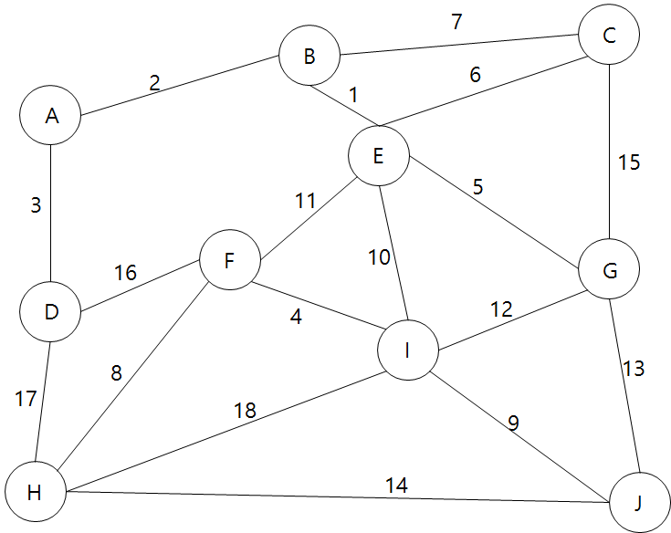  1) Kruskal’s algorithm  Add edge of minimum weigh and if it makes cycle, delete last edge.  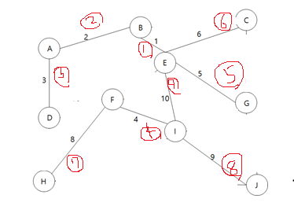  2) Prim’s algorithm(starting from vertex A)  (A,B) -> (B,E) -> (A,D) ->(E,G) -> (E,C) -> (E,I) -> (F,I) -> (F,H) -> (I,J)  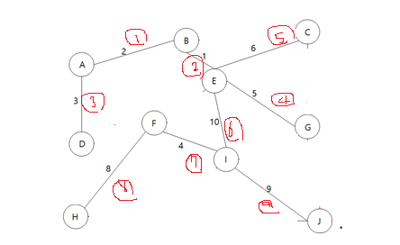  3) Sollin’s algorithm  first stage: (A, B), (B, E), (A, D), (E, C), (F, I), (G, E), (F, H), (I, J)  second stage: (E,I)  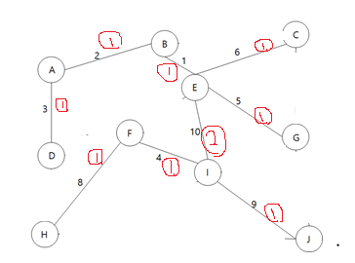
Problem 2  [15 points] |   Compute the costs of shortest paths home to the other locations using Dijkstra algorithm.  Describe the all steps to find the shortest paths.  Beauty parlor(5) : HomeBeauty parlor(5)  Supermarket(8) : HomeBeauty parlor(5)Supermarket(3)  Educational institute(9) : HomeEducational institute(9)  Restaurant(11) : HomeBeauty parlor(5)Supermarket(3)Restaurant(3)  Bank(15) : HomeBeauty parlor(5)Supermarket(3)Restaurant(3)Bank(4)  School(17) : HomeBeauty parlor(5)Supermarket(3)Restaurant(3)Bank(4)School(2)
  order | Node  name | Cost of minimum cost path
  1 | Beauty parlor | 5
  2 | Supermarket | 8
  3 | Educational  institute | 9
  4 | Restaurant | 11
  5 | Bank | 15
  6 | School | 17
Problem 3  (25 points) | 1) Write appropriate comments in ①, ②, ③ to explain the purpose of the following module. (6 points)  int choose(int distance[], int n, int found[])  {  int i, min, minpos;  min = INT_MAX; /* ① */  minpos = -1;  for (i = 0; i < n; i++)  if (distance[i] < min && !found[i]) {/* ② */  min = distance[i]; /* ③ */  minpos = i;  }  return minpos;  }  ①  If I put INT_MAX in min, the comparison target can be min because it is always large compared to the other.  ②  distance[i] is smaller than min and it isn’t founded.  ③  change min value to find minimum. This saves the minimum distance.  2) Write appropriate comments in ①, ②, ③ to explain the purpose of following module. (6 points)  void shortestPath(int v, int cost[][MAX_VERTICES],  int distance[], int n, short int found[])  {  int i, u, w;  for (i = 0; i < n; i++) {  found[i] = FALSE;  distance[i] = cost[v][i];  }  found[v] = TRUE; distance[v] = 0;  for (i = 0; i < n-2; i++) {  u = choose(distance, n, found); /* ① */  found[u] = TRUE;  for (w = 0; w < n; w++)  if (!found[w])  if (distance[u]+cost[u][w] < distance[w]) /* ② */  distance[w] = distance[u]+cost[u][w]; /* ③ */  }}  U is the edge that has minimum distance from n.  Check if there is a shorter value than the previous minimum length.  If there is a shorter path, change it to the value.  3) From the code in 2), we can find out the cost of shortest paths but not the path.  Modify the code to print out the path as well as the cost. If it is necessary, you can define new variable or design new module (13 points)  void shortestPath(int v, int cost[][MAX_VERTICES],  int distance[], int n, short int found[])  {  int i, u, w, k=1;  int path[MAX_VERTICES];  path[0] = v;  for (i = 0; i < n; i++) {  found[i] = FALSE;  distance[i] = cost[v][i];  }  found[v] = TRUE; distance[v] = 0;  for (i = 0; i < n-2; i++) {  u = choose(distance, n, found);  found[u] = TRUE;  for (w = 0; w < n; w++)  if (!found[w])  if (distance[u]+cost[u][w] < distance[w])  distance[w] = distance[u]+cost[u][w];  path[k]=u;  k++;  }}  for(int j=0;j<k; i++){printf(“%d”,path[j]);}
Problem 5  (45 points) | Develop a program to calculate the shortest paths from any selected city to all the other cities. Make use of the code in the problem 3.  ① A user can select “Input graph”, “Compute the shortest paths”, “Quit”  ② When the user selects “Input graph”, the program requests number of vertices, city name correspond to vertex and road information between cities as input data. If a user want to stop insert data, enter ‘.’ to the blank line. The city name is maximum 20 characters and consist of only alphabet. The graph can have maximally 10 vertices.  Example)  suwon seoul daegu incheon daejon  suwon-seoul 10  suwon-incheon 50  seoul-daegu 100  suwon-daegu 150  suwon-daejon 50  seoul-daejon 22  seoul-incheon 25  ③ When the user select “Compute the shortest paths”. The program requests ‘Source city’ as input data. The program shows shortest paths from input to all the other cities and its costs. The user can use this “Compute the shortest paths” menu several times before the program terminates.  Example) suwon  seoul : 10 suwon seoul  daegu : 132 suwon seoul daegu  incheon : 35 suwon seoul incheon  daejon : 32 suwon seoul daejon  ④ When the user select ‘Quit’ the program prints a farewell message and terminates.  #include <stdio.h>  #define INT_MAX 2147483647  #define TRUE 1  #define FALSE 0  #define MAX_VERTICES 5  #define INF 1000  int weight[MAX_VERTICES][MAX_VERTICES] = {  {0,10,150,50,50},  {10,0,100,25,22},  {150,100,0,INF,INF},  {50,25,INF,0,INF},  {50,22,INF,INF, 0},  };  int distance[MAX_VERTICES];  int found[MAX_VERTICES];  int path[MAX_VERTICES][MAX_VERTICES];  int check[MAX_VERTICES];  void path_init(int path[][MAX_VERTICES]);  int choose(int distance[], int n, int found[]);  void shortest_path(int start, int n);  void main() {  int i, j;  int start, a, b, c,d;  char city1[100], city2[100];  char city[6][10] = { "suwon","seoul","daegu","incheon","daejon"};  path_init(path);  while (1) {  printf("What will you do?\n");  printf("1.Input graph 2.Compute the shortest paths 3. Quits\n");  scanf("%d", &a);  if (a == 1) {  printf("How many city you want?\n");  scanf("%d", &b);  printf("input two city and road information\n");  do {  scanf("%c", &city1[100]);  } while (getchar() != '.');  }  else if (a == 2) {  printf("출발 지점을 선택하시오\n");  printf("0.suwon 1.seoul 2.daegu 3.incheon 4.Daejon\n");  scanf("%d", &start);  printf("\n");  shortest_path(start, MAX_VERTICES);  for (i = 0; i < MAX_VERTICES; i++) {  printf("%s : ", city[i]);  printf("%d ", distance[i]);  for (j = 0; j < MAX_VERTICES; j++) {  if (path[i][j] != INF) {  d = path[i][j];  printf("%s->", city[d]);  }  }  printf("%s\n", city[i]);  }  }  else if (a == 3) {  printf("bye bye!\n");  break;  }  }  }  void path_init(int path[][MAX_VERTICES]) {  int i, j;  for (i = 0;i<MAX_VERTICES;i++)  for (j = 0;j<MAX_VERTICES;j++)  path[i][j] = INF;  }  int choose(int distance[], int n, int found[]) {  int i, min, minpos;  min = INT_MAX;  minpos = -1;  for (i = 0;i<n;i++)  if (distance[i]<min && !found[i]) {  min = distance[i];  minpos = i;  }  return minpos;  }  void shortest_path(int start, int n)  {  int i, j, u, w;  for (i = 0; i<n; i++) {  distance[i] = weight[start][i];  found[i] = FALSE;  check[i] = 1;  path[i][0] = start;  }  found[start] = TRUE;  distance[start] = 0;  for (i = 0; i<n - 2; i++) {  u = choose(distance, n, found);  found[u] = TRUE;  for (w = 0; w<n;w++) {  if (!found[w]) {  if (distance[u] + weight[u][w] < distance[w]) {  if (i == 0) {  path[w][check[w]] = u;  check[w]++;  }  else {  for (j = 0; j<(check[u] + 1); j++) {  path[w][j] = path[u][j];  path[w][j + 1] = u;  check[w]++;  }  }  distance[w] = distance[u] + weight[u][w];  }  }  }  }  }

